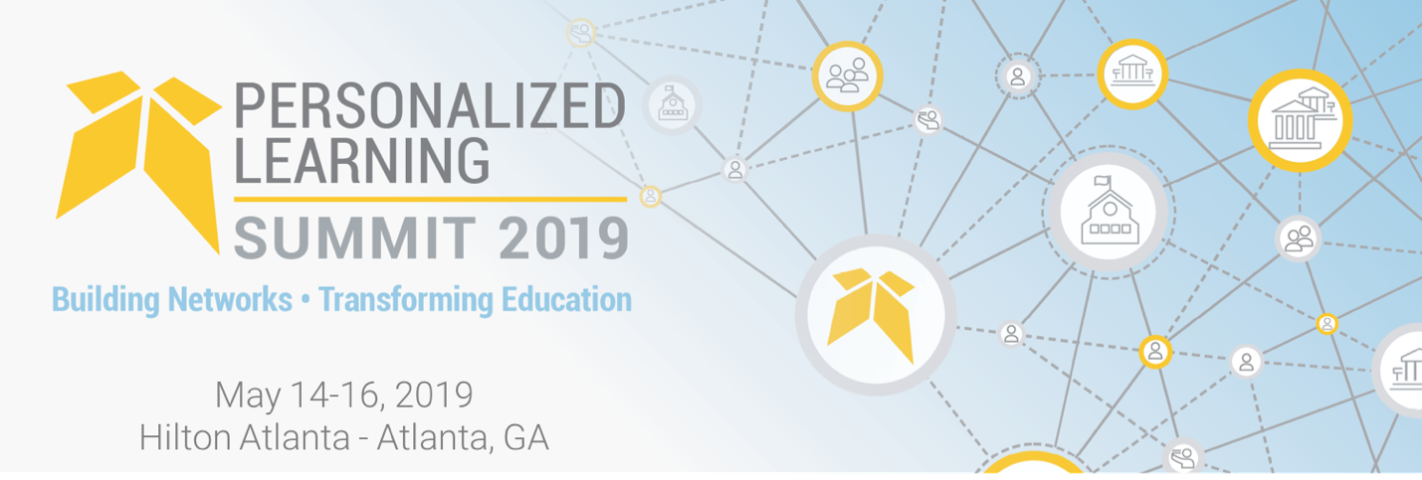

Dear [Name]:

I am writing to request approval for funding to attend the Education Elements Personalized Learning Summit.

The 5th annual Personalized Learning Summit will bring together 750 innovative district leaders and educators on May 14-16, 2019. These leaders represent districts at every stage of their personalized learning journey, from those who pioneered personalized learning to those just getting started, so that everyone can learn from one another, as well as from experts in the field.

This three-day in-person event is full of professional development opportunities, dynamic and engaging sessions, networking events, inspiring and insightful keynotes, and tours of some of the most innovative companies in Atlanta, GA.

My participation at the summit will progress my professional development, and equip me with tangible tools and resources to improve our district’s understanding, implementation and growth of personalized learning.

I’m writing to request that [district] supports this unique opportunity for me and the district by covering my expenses to attend in Atlanta, May 14-16, 2019.

Here are some of the benefits of attending:

- Learn strategies and tactics that we can apply to engage students, teachers, and our community
- Get a sense of what leading edge districts are doing to implement personalized learning at scale
- Return to work inspired and full of new ideas and resources to share with the team
- Have a new network of professional contacts I can continue to learn from

The ticket price is [$660.00 if early bird, $825 if full price] for all 3 days, and includes all meals on Wednesday and breakfast and lunch on Thursday. I estimate [amount] in travel costs, for a total of [total].

Thank you for your consideration.

